Team Project:

Deliverable 1 - Proposal

CSCE 5430 (Fall 2020)

1. A project title, group name, and group members’ names.

* **Project Title:** The Bowl
* **Group Name:** Brute-Force
* **Team Members:**

1. Akhil Kata
2. Ganesh Bommisetty
3. Siva Kumar Sri Sai Pulavarthy
4. Sandeep Gangullapattu
5. Shasidhar Jampana
6. Satish babu Nalajala
7. Pramodh chava
8. A project description: a detailed description of the system you plan to develop including development environments (language, platform, and so on).

* **Project Description**:

The primary motive of our project “The Bowl” is to provide the user with an online booking service which serves food. The project consists of the below main functionalities:

1. User Registration:

* A user must register in the sign-up pageif he/she is a new user.

1. Login:

* If the user is a existing user he/she can directly login to the website

1. Place an order:

* After Logging into the website the website show all the food items that are available in the restaurant, so the user can select the items he needed to order.

1. Cancel an Order:

* If a user order’s a wrong item or if he/she not interested in some particular reasons. They can cancel the order.

1. View Order:

* After the user placing the order he can preview the orders he has ordered.

1. Payment method:

* The user can choose the payment method based on the user’s preferences like card payment , cash payment, Third-party apps
* Programming Language: Html/ Css boot-strap, Java Script, My Sql, Java

Generally, if a new user wants to book a ticket for an event from our website, they need to register/sign up. In this step the user need to enter various fields like First Name, Last Name, Phone number, email id, username and password. After registering with the details they can login into the website with their username and password. If a user is already an existing user, they can directly login with the username and password.

This website consists of various rice bowls and food items where the user can order the food as per their preference. Once the user selects the food he/she can see the preview the food ordered, and then it direct the user to the payment page.

1. A top-level plain text document called README that lists the directory (folder) structure of your project directory.
2. A directory (folder) structure that includes areas for the project source code, planning documents, meeting minutes, and project reports.
3. *An initial set of meeting minutes (time, attendees, things discussed, and etc.).*

Meeting 1

In Person Meeting, 08/31/2021-- 05:00 PM to 8PM

Attendees-

* Siva Kumar Sri Sai Pulavarthy
* Ganesh Bommisetty
* Akhil Kata
* Shasidhar Jampana
* Sandeep Gangullapattu
* Satish Babu Nalajala

Things Discussed-

* Design Ideas and approaches.
* Outlining Approaches Based on Every Individual’s Views.
* Created Project Meeting Schedule.
* Front End, Back End, and Database Role distribution.
* Identified Potential Challenges of the Project.

Meeting 2

In person meeting, 09/03/2021—10 AM to 2 PM

Attendees-

* Siva Kumar Sri Sai Pulavarthy
* Ganesh Bommisetty
* Akhil Kata
* Shasidhar Jampana
* Sandeep Gangullapattu
* Satish Babu Nalajala
* Pramodh Chava

Things Discussed-

* Refreshed Submissions into Trello.
* Created Events for the project.
* Distributed Technical Roles according to skill sets.
* Formulated Gantt chart.
* Designed PowerPoint Presentation for the project.
* Distributed workload for creating Deliverable 1.
* Assessed each other and gave scores based on work done.

Meeting 3

Zoom meeting, 09/08/2021—11AM-12AM

Attendees-

* Siva Kumar Sri Sai Pulavarthy
* Ganesh Bommisetty
* Akhil Kata
* Shasidhar Jampana
* Sandeep Gangullapattu
* Satish Babu Nalajala
* Pramodh Chava

Things Discussed-

* Added pramodh to the group and discussed the idea of the project
* Shared the ideas and skill set
* Included pramodh and assigned works accordingly.

1. Risk management (content described above).

Risk Management:

* Risk management is a key factor in Food delivery system. It is the process of elimination the possible risks that are going to happen while login into the website till he done with his payment.
* It involves four steps called risk identification, risk measurement, risk mitigation and risk review and monitoring. There are multiple risks involved in Food delivery booking. We have discussed and came up with the following top 3 risks.

|  |  |
| --- | --- |
| **Risk** | **Maintenance** |
| **Risk monitoring** | * Recognize website improvement needs. * Check for website errors and broken links. |
| **Risk evaluation** | * Proper strategy for maintenance. * Execute problem reporting techniques. |
| **Contingency plan** | * Create a user- assist category. * Update web design with graphics and photos. |

|  |  |
| --- | --- |
| **Risk** | **Security** |
| **Risk monitoring** | * Exploitability * Prevalence |
| **Risk evaluation** | * Ease of detection * Technical impact |
| **Contingency plan** | * Backup the website * Create firewalls * Standard adherence |

|  |  |
| --- | --- |
| **Risk** | **Schedule Risk** |
| **Risk monitoring** | * Recognize website improvement needs. * Check for project deadlines. |
| **Risk evaluation** | * Proper project planning * Optimized improvements in the project. |
| **Contingency plan** | * Keep track of available time. |

1. An initial planning that lays out the big timeline for your project and expected milestones. Include Gantt and/or PERT charts where appropriate. This will be modified in later deliverables. At this point, you do not have enough details to develop a complete plan, but you can do a high-level planning exercise. Please refer to the deliverable deadlines posted on the Canvas to make a plan. Use KanBanboard to track the project schedule including each member’s status.

Gantt chart:

It is gannt chart which show the delivery times, demos and project dead-lines of the project. It is the basic gannt chart for the initial stage of the project, where we are going to update the further tasks and milestone in the upcoming days.

We have finalized our models into two they are:

1. Admin model
2. User model

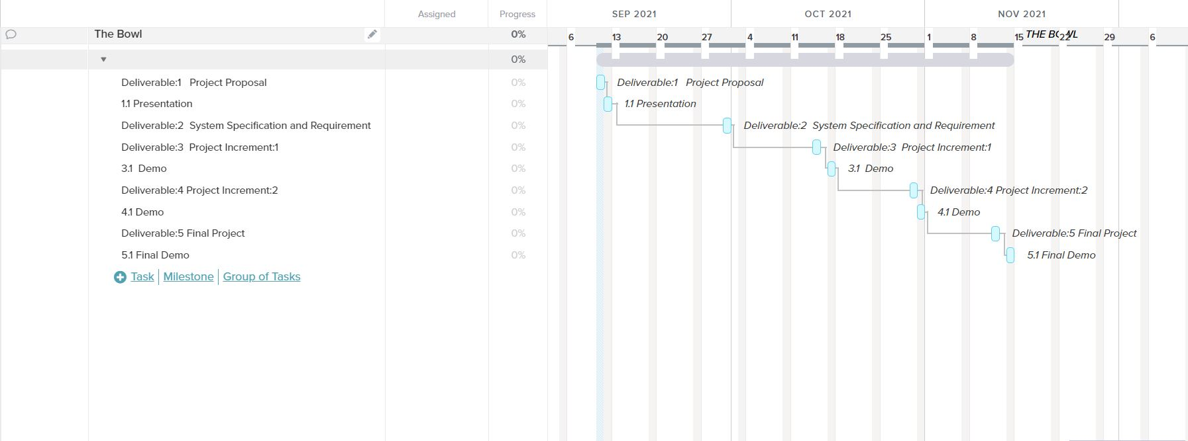

1. A section that describes each team member’s roles for the project:
2. Siva Kumar Sai Pulavarthy: Backend development and front end development
3. Shasidhar Jampana: Front-end and Back-end development
4. Ganesh Bommisetty: Front-end and Back-end development, Documentation
5. Akhil Kata: Database and Back-end development, Documentation
6. Sandeep Gangullapattu: Testing and Front-end development
7. Satish Babu Nalajala: Testing and documentation
8. Pramodh Chava: Testing and documentation

9)Member contribution table (should describe who wrote what parts of the report). Add more rows as needed.

|  |  |  |  |
| --- | --- | --- | --- |
| Member name | Contribution  Description | Overall  Contribution(%) | Note  (if applicable) |
| 1. Siva Kumar Sai Pulavarthy | Github Repo,Trello Creater, Project Functionality | 100% |  |
| 2. Ganesh Bommisetty | Deliverable :1  Risk management, gantt chart, meeting minutes | 100% |  |
| 3. Akhil Kata | Power point documentation, communicating between the team members | 100% |  |
| 4.Shasidhar Jampana | Project description , Module Segmentation, | 100% |  |
| 5. Sandeep Gangullapattu | Power point, Domin Knowledge | 100% |  |
| 6. Satish Babu Nalajala | Time Scheduling, | 100% |  |
| 7. Pramodh Chava | Board management, evaluation | 100% |  |